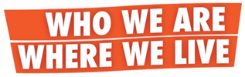
Community Reading and Celebration
Open to all Greater Clevelanders and Visitors
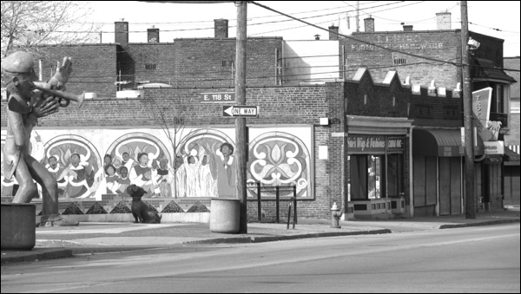
A culmination of the Who we are, Where we live Program, featuring
Buckeye-Shaker neighborhood stories, and introducing the
Who we are, Where we live website and online anthology.

Saturday, July 8, from 1 pm to 3 pm
Loganberry Books
13015 Larchmere Blvd., Cleveland

1:00 Appetizers and refreshments

1:30 A dynamic reading by workshop participants and
anthology contributors

2:15 Free raffle drawings for books and great prizes
Connecting with friends, old and new!

There’s still time to be part of the story.
For more info contact Program Director: Cindy Washabaugh at 216-403-5326
Email: info@litcleveland.org or cindywashabaugh1@gmail.com
Free! To register, visit http://www.litcleveland.org/who-we-are-where-we-live.html

